Managing Relationships at
Work

Working with others…

By it’s very nature working on farm often requires working alone, whether that is because of the task at hand or the fact that farm size doesn't allow for a bigger team. However, teamwork can achieve more than individuals working in isolation, and many farmers welcome an extra pair of hands when offered!

As a manager, how you facilitate team working makes a huge difference to the outcomes achieved.
“The fish smells from the head down”
Jonathan Winchester
is a statement which holds true for every institution and organisation. Think about schools, hospitals, charities, workplaces; they are all only as good as the person leading them. The same is true of your organisation.

In line with the stated Vision and Mission statements you will set and monitor the values, standards, behaviour and moral integrity of your organisation and they will reflect your own personal thoughts on what is important.

Think about the values you want your workplace to uphold; remember for farmers and growers this may reflect your environmental values as well. What is important to you, and how do you personify it?
Value | How you personify it;

For any task that needs to be achieved, three fundamental parts of it need to be managed.
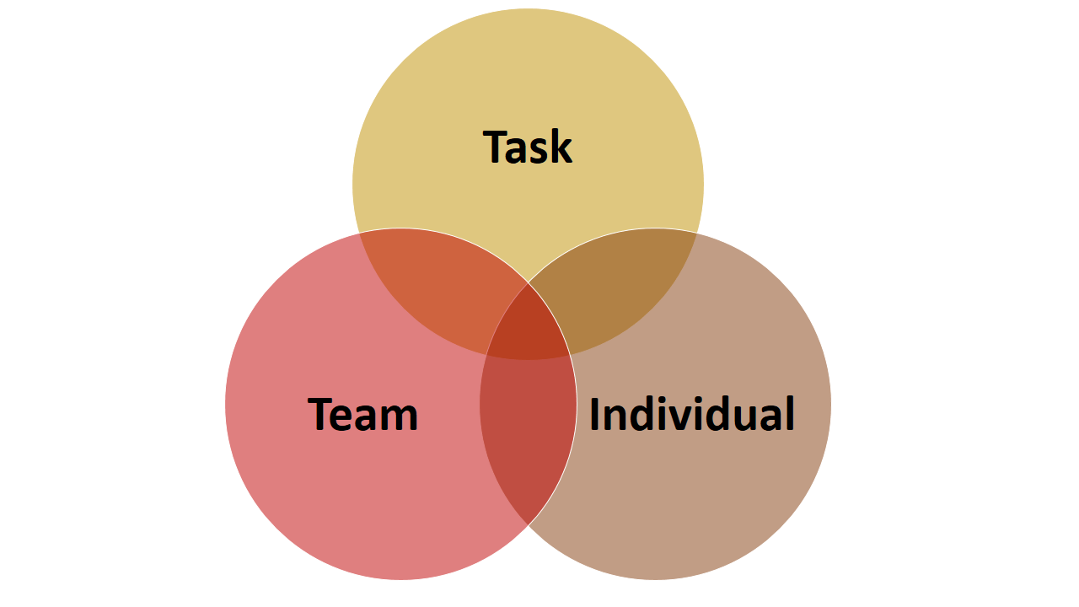
When a new task becomes necessary what do you need to think about in terms of managing that task to ensure its successful completion)?
…………………………………………………………………………………………………………………………………………..

…………………………………………………………………………………………………………………………………………..

…………………………………………………………………………………………………………………………………………..

…………………………………………………………………………………………………………………………………………..

…………………………………………………………………………………………………………………………………………..

…………………………………………………………………………………………………………………………………………..

…………………………………………………………………………………………………………………………………………..

…………………………………………………………………………………………………………………………………………..

…………………………………………………………………………………………………………………………………………..

…………………………………………………………………………………………………………………………………………..

…………………………………………………………………………………………………………………………………………..

Hopefully you have thought about some of the following.
- define the activity (the task)
- identify resources, people, processes, systems
- create the plan to achieve the task - deliverables, measures, timescales, strategy, and tactics
- establish responsibilities, objectives, accountabilities, and measures, by agreement and delegation
- set standards, quality, time, and reporting parameters
- control and maintain activities against parameters
- monitor and maintain overall performance against plan
- report on progress towards the group's aim
- review, re-assess, adjust plan, methods, and targets as necessary
However, none of this will be achieved unless you think about the relationships between the team members, including both as a team and individually.
What do you need to think about when managing the team?
…………………………………………………………………………………………………………………………………………..

…………………………………………………………………………………………………………………………………………..

…………………………………………………………………………………………………………………………………………..

…………………………………………………………………………………………………………………………………………..

…………………………………………………………………………………………………………………………………………..

…………………………………………………………………………………………………………………………………………..

…………………………………………………………………………………………………………………………………………..

…………………………………………………………………………………………………………………………………………..

…………………………………………………………………………………………………………………………………………..

…………………………………………………………………………………………………………………………………………..

…………………………………………………………………………………………………………………………………………..

Have you thought of how to;?
- communicate standards of performance and behaviour
- establish style, culture, approach of the group
- monitor and maintain discipline, ethics, integrity and focus on objectives
- anticipate and resolve group conflict, struggles or disagreements
- assess and change as necessary the balance and composition of the group
- develop team-working, cooperation, morale
- develop the collective maturity and capability of the group – enable empowerment
- motivate the team towards objectives and aims
- identify, and agree team - and project - leadership roles
- ensure effective group communications
- identify and meet group training needs
- give feedback to the group on overall progress; consult with, and seek feedback and input from the group
Finally, how do you ensure everyone feels valued as an individual?
…………………………………………………………………………………………………………………………………………..

…………………………………………………………………………………………………………………………………………..

…………………………………………………………………………………………………………………………………………..

…………………………………………………………………………………………………………………………………………..

…………………………………………………………………………………………………………………………………………..

…………………………………………………………………………………………………………………………………………..

…………………………………………………………………………………………………………………………………………..

…………………………………………………………………………………………………………………………………………..

…………………………………………………………………………………………………………………………………………..

…………………………………………………………………………………………………………………………………………..

…………………………………………………………………………………………………………………………………………..
Have you included?
- understand the team members as individuals - personality, skills, strengths, needs, aims ambitions and fears (also see https://projectblue.blob.core.windows.net/media/Default/Onboarding pages/Differentstrokesgenerationaldifferences1_220606_WEB.pdf
- assist and support individuals - plans, problems, challenges, highs, and lows
- identify and agree appropriate individual responsibilities and objectives
- give recognition and praise to individuals - acknowledge effort and good work
- where appropriate reward individuals with extra responsibility, advancement, and status
- identify, develop, and utilise everyone’s capabilities and strengths
- train and develop individual team members
- develop individual freedom and authority

Leading the team

“There is no I in TEAM”
Where it is possible, team working tends to produce more than the sum of its parts. However, the leader of the team is key to ensuring that the team works in a cohesive and supportive manner.
As mentioned in the previous section and thinking about the skills discussed in the Managing Staff Performance and Development workbook, setting the objectives for the team rather than a collective of individual objectives is vital. (Also see https://ahdb.org.uk/setting-objectives )
- Remember to set SMART (Specific, Manageable, Achievable, Realistic and Time-bound) objectives for each task, and then monitor activity against them.
- You are responsible for the ethos of the team, which involves everyone supporting each other, with a ‘can do if’ attitude, not a ‘yeah, but1 frame of mind.
- You must ensure everyone pulls their weight and contributes equally to achieving the objectives.
Thinking about the last task you set for your team, how did you.
Set SMART objectives

Allocate tasks according to capability

Create a plan

Monitor progress

Feedback the outcome of the monitoring

Adjust the plan as necessary

Offer encouragement and support

Giving Feedback
Giving feedback is a vital skill for Managers and Leaders and should be a continuous process, not something only done when there is a problem.
Feedback is really important to.
- define key issues at strategic and departmental level
- motivate – an opportunity to say well done on a good job
- share best practice
- encourage your team to improve their performance
- increase performance through internal competition
- improve customer experience (where relevant)
- make life at work more enjoyable

“Feedback stimulates a positive, development-orientated process that leads over time, to learning, behaviour change and performance improvement”

Feedback can be carried out as a group.
- general positive WWW (what went well) discussion
- general probing EBI (even better if…) discussion
- opportunity for whole team discussion and training
Or as an individual;
- opportunity to praise specific strengths
- can identify and discuss ways to address weaker areas

Think about the last time you gave feedback; how did you prepare for the process?
1………………………………………………………………………………………………………………………………………..

2………………………………………………………………………………………………………………………………………..

3………………………………………………………………………………………………………………………………………..

Did you?
- prepare yourself
- prepare what to say and how you are going to say it
- prepare the environment?

What are the three types of feedback you can give?
  - Affirming strengths and positive behaviours that have a good impact on the business and/or relationships
  - May look to extend positive - strengths, behaviours that could be used in new areas
Positive
  - Addressing weaknesses or behaviour that have a neutral or negative impact on the business and/or relationships
Developmental
  - Addressing serious, non-negotiable weaknesses or behaviour that have a significant negative impact on the business and/or relationships
Confronting an Issue

Think about how you would give positive feedback. What sort of phrases might you use?

1………………………………………………………………………………………………………………………………………..

2………………………………………………………………………………………………………………………………………..

3………………………………………………………………………………………………………………………………………..

Feedback designed to confront an issue can be harder to give, and a model might help make it easier for you, the BEEF model;
- Name the behaviour, action, or issue
Behaviour
- Select a specific example that illustrates the behaviour or situation you want to change
Example
- Describe the impact on you, others, or the task. Describe your emotions. Clarify what is at stake
Effect
- Indicate your wish to resolve the issue. Invite your team member to respond.
Future

For maximum effect this should be combined with the GROW model.
- Set SMART objectives
Goal
- What is happening now? What resources do we need?
Reality
- What are our options for action? What obstacles might there be?
Options/
Obstacles
- What can we commit to, by whom and when?
What next?

Thinking about giving feedback designed to confront a specific issue, prepare by completing the following.

Model stage. | Planned conversation;
Behaviour

Example

Effect

Future

Goal

Reality

Options/Obstacles

What next?

Can you see how this helps you to structure the conversation and make it motivational?
Also see https://ahdb.org.uk/skills/communication and https://www.dairynz.co.nz/people/people-resources/?subject/topic=36457

Managing Conflict in teams
Even in the most harmonious teams there can sometimes be conflict, and this is where your skill as a Leader or Manager is really tested.
You must be seen to be totally fair and impartial and facilitate a workable compromise being reached.
The steps to achieving this are;
- speak to all concerned, LISTEN carefully and gather as much information about the situation as you can
- use open questions to ensure you have covered all the relevant points and that you have a clear view of the issue
- repeat the information back to people to check your understanding (if necessary, LISTEN again)
- stay objective, open minded, and where possible focus on facts rather than emotion
- offer the wider perspective including how the issue will affect the broader team
- agree the way forward; the issue will not go away without resolution, so ensure you have commitment from all involved team members.
Thinking of a conflict you have had to deal with, how did you manage these points?
Speak to all concerned, LISTEN carefully and gather as much information about the situation as you can

Use open questions to ensure you have covered all the relevant points and that you have a clear view of the issue

Repeat the information back to people to check your understanding (if necessary LISTEN again)

Stay objective, open minded, and where possible focus on facts rather than emotion

Offer the wider perspective including how the issue will affect the broader team

Agree the way forward; the issue will not go away without resolution, so ensure you have commitment from all involved team members.

Keeping everyone Informed
It is very important all team members are kept informed of any events relevant to the Organisation, and most particularly those events relevant to them. Where there is a vacuum of information, gossip fills in the space, so accurate information is essential, even if it is not good news.

How do you ensure everyone is kept informed in an accurate and timely fashion? Think of the different strategies you can use, who they are most suited to and what sort of information they are most appropriate for;

Communication method | Who is it suited to? | Appropriate information

Different demographics prefer different methods of communication, so by using a range of options you can keep all your team members informed. Possible options are face to face or virtual meetings, e-mails, WhatsApp, Facebook, intranets, or visual noticeboards.

Make sure anything you tell people you also try and record somewhere in writing, as some people prefer to take in information verbally, others through the reading the information. Think about how you disseminate information; do you have a set meetings structure that covers all the people in the organisation? How do you make sure everyone hears the information? This can be particularly challenging for part time team members, people who usually work alone or those who work different shifts. You might also have the challenge of working with team members where English is not their first language; how do you ensure they are kept fully informed and feel included?

Thinking about the last time you had to make an important announcement to your team, how did you make sure you covered everyone?
…………………………………………………………………………………………………………………………………………..

…………………………………………………………………………………………………………………………………………..

…………………………………………………………………………………………………………………………………………..

…………………………………………………………………………………………………………………………………………..

…………………………………………………………………………………………………………………………………………..

…………………………………………………………………………………………………………………………………………..

…………………………………………………………………………………………………………………………………………..

…………………………………………………………………………………………………………………………………………..

…………………………………………………………………………………………………………………………………………..

…………………………………………………………………………………………………………………………………………..

…………………………………………………………………………………………………………………………………………..

Working effectively with ALL your team members
To be a truly effective team leader you need to have Emotional Intelligence, and a theorist called Daniel Goleman has succinctly defined what this means;

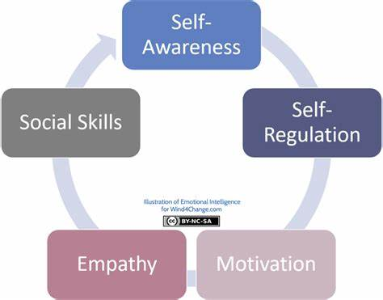
https://wind4change.com/emotional-intelligence-daniel-goleman-work-self-mastery/
There is a few studies by O’Leary et al. showing a 40 % correlation between emotional intelligence and profitability on dairy farms in England and Wales. (See further resources)
What do you think is meant by;?
Self Awareness

Self Regulation

Empathy

Motivation

Social Skills

Self-Awareness is about your view of yourself being objective and open; not thinking you are something you aren’t.
Self-Regulation ensures you don’t REACT to situations, you RESPOND to them. This allows a more measured, thoughtful response rather than a knee jerk reaction.
Empathy is the ability to understand and share the feelings of others, even if you are unable to totally accommodate them
Motivation enables you to tackle each situation with energy and enthusiasm, maintaining a positive outlook on your role and enjoying what you are doing. This enables full commitment and real presence.
Social skills are ways of interacting with others that make it easier to succeed socially. They allow you to communicate effectively and understand what others are trying to communicate to you, both verbally and non-verbally.
To succeed as a team leader, strive to;
• listen to others properly
• pay attention to others’ emotional cues (watching their body language, for example)
• bring people into conversations and discussions where they should be included but are being left out
• know when to give a person space – keeping quiet or moving away
• communicate using language and media that the other person/ people understand and feel comfortable with
• own your own opinions and judgements (e.g. ‘I think/feel that…’ instead of making sweeping statements like ‘Everybody knows that…’)
• always act with integrity, consistency, and authenticity, so that others know they are trustworthy
• stay positive, calm and hopeful as well as realistic when discussing problems and issues
• be assertive (respecting one’s own AND others’ rights and boundaries) rather than aggressive (ignoring other people’s rights and boundaries), passive (allowing another person’s aggression towards you) or passive-aggressive (not guarding your own rights/boundaries AND not respecting those of others

Thinking about recognising achievements;
Think of two achievements colleagues have made recently

How did you recognise these?

How did you celebrate what they had achieved?

How did they feel about this?

Thinking about respect, fairness and courtesy;
Think of a situation where you were NOT treated courteously recently…

How did you respond to that? How did it make you feel?

How could you have responded in an emotionally intelligent way?

Thinking about agreements;
Name two agreements you have made with colleagues recently;

How have you met those agreements?

If you are having a problem meeting an agreement how do you communicate that to your colleague?

Thinking about giving feedback;
Think of three ways you can constructively support your team members

How many times do you offer feedback, good or developmental in an average week?

Could you do it more often? Think of some opportunities

Describe two instances of giving feedback, one positive, one developmental

How do you encourage your team to give YOU constructive feedback; think about how you will respond to it!

Solving problems collaboratively
It doesn’t matter how well you lead your team, there will always be problems to deal with. The better the relationship you have with your team, and the more you trust them, the more they can help you address any issues that arise. They will find this very motivational and empowering, and it should help you think of more creative and innovative solutions which will make your workplace more resilient going forward.
Despite all your best efforts, you will not have the same relationship with all your team members.
Think of a team member you would like to understand better. Thinking of life from THEIR perspective, how can you empathise with their situation more fully?

1………………………………………………………………………………………………………………………………………..

2………………………………………………………………………………………………………………………………………..

3………………………………………………………………………………………………………………………………………..

The ability to see things from another person’s perspective is a vital skill. In fact, true communication cannot happen without it, and you will not be able to appreciate and ‘leverage’ others’ viewpoints without this ability. One of the most successful problem-solving (and conflict managing) techniques – Fisher and Ury’s ‘principled negotiation’ – relies heavily on really understanding the viewpoints of all involved. This approach urges you to identify and share your ‘interest’ in the solution of any problem – rather than identifying and sticking to your ‘position’ – and to encourage others to do the same. https://www.atlas101.ca/pm/concepts/fisher-and-urys-four-principles-of-negotiation/
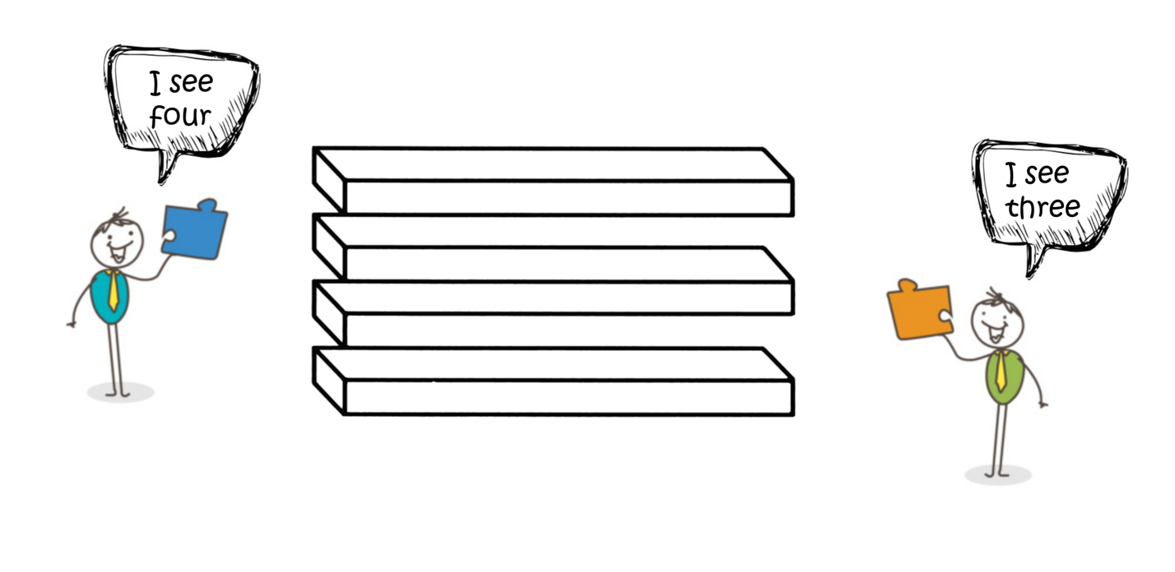
Think about the Fisher and Ury model of negotiation
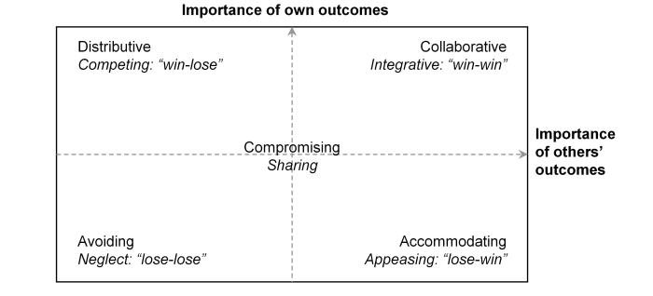
where compromise is always the only win-win answer.
Describe when you actively sought other people’s opinions when solving a problem

How did you do it? How did you remain neutral and not express your own view?

How did seeking another point of view help you to solve the problem?

Some Managers and Team Leaders feel it is a sign of weakness to consult with their colleagues, but actually this demonstrates strength. However you must be prepared to make a final decision and justify how and why you have come to that conclusion. To do this successfully you must be confident in your role and confident in your communication skills to persuade other people to accept your decision.
You must also know when you need to seek permission from people more senior than you when necessary, assuming there is someone else to consult!
Describe a situation where you have had to take a problem to someone more senior than you

Describe a problem which affects your team but where the decision must be taken by someone else

Describe a problem you are happy to delegate to be solved

How do you know if your answers so far are correct?

Now describe a problem you have solved successfully in consultation with others

In order to minimise disruption in the workplace, compromise is much more effective than taking a position and sticking to it!! For maximum results communication, negotiation and compromise are the most effective options.

Further resources
O’Leary NW, Tranter R, Bennett R. Are farmer personality traits associated with farm profitability? Results from a survey of dairy farmers in England and Wales. Int J Agric Manag. 2018;7(2):17-25. Doi:10.5836/ijam/2018-07-17
Are farmer personality traits associated with farm profitability? Results from a survey of dairy farmers in England and Wales
https://centaur.reading.ac.uk/80737/
https://ahdb.org.uk/skills/communication
https://www.youtube.com/watch?v=r7lf8tQrUA0 AHDB Talking Leaders -Negotiation: How to Get the Result You Want – With Nick Davies

Watch
https://youtu.be/F28waw6dz-I
https://www.youtube.com/watch?v=6NlMenE6rTE&t=6s

Read
https://projectblue.blob.core.windows.net/media/Default/Skills/AHDB Team Boost Workbook 1.pdf
Read and do [quiz] https://projectblue.blob.core.windows.net/media/Default/Skills/Communication/Communication styles quiz v1.1.pdf

